

A machine learning approach to quantitative and qualitative analyses of the state of Black mental health in England & Wales, and the potential value of a digital Black-centred intervention.

C0M00151M Independent Research Project

MSc Computer Science with Data Analytics

Joshua Eserovweoghene Ibuanokpe

Farid Bello (Supervisor)

# Acknowledgements

I would firstly like to thank my personal support system that includes my parents, my brother & his family, my sister, my “mother-in-law” and my close friends. I would also like to especially thank my partner Florence who has tolerated my early starts and late nights in chasing this MSc, but beyond that faithfully supports my efforts to try and improve myself so we can have a brighter future together.

I would also like to thank my supervisor Farid for his support and keen interest throughout the 18 weeks, and to Habes for stepping in in his place while Farid was on annual leave.

Finally, I would like to thank everyone who participated in the survey. Though I do not know everyone who supported the research, their insights have been invaluable, and I hope I have been able to capture and represent their feelings and opinions in this report. I hope this start can inspire positive change and further research into prioritising and supporting better mental health outcomes for people of Black heritage in this country and beyond.

# Executive summary

This investigation aimed to utilise a mixed methods approach to understand the state of mental health for Black and Mixed Black people in England & Wales. The motivation being to address the problem that Black and Mixed Black people are more likely to have poorer mental health and social outcomes. The investigation involved a quantitative analysis of available data on the localisation of Black and Mixed Black people and mental health incidence in these regions, a qualitative analysis of the opinions of adults who live in England & Wales of Black or Mixed Black heritage, and a computational analysis of survey responses to determine if machine learning methodologies can extract sentiment in the context of Black mental health.

Maps were produced using data from UK Census, Indices of Multiple Deprivation and NHS Digital to provide high-level insight into Black and Mixed Black geographic distributions and mental health incidence.

The survey gathered information on how participants felt about various topics surrounding mental health in the Black community. It combined open-text questions with Likert-scale questions for the same topic, so written opinions could be compared against their scoring of how positively they feel about it. This provided structured data for sentiment analysis, with features being text answers and labels being Likert-scale answers. A pre-trained lexicon-based NLP model, Twitter-roBERTa-base for sentiment analysis, was selected as a baseline, against which the performance of three machine learning algorithms (Linear Regression, Support Vector Regressor, Random Forest Regressor) were compared. All models did not successfully predict the sentiment of the survey answers against the self-reported positivity scores, with a peak accuracy of 30.77% from the baseline model and a peak precision of 51.54% from the Support Vector Regressor. Survey answers were then grouped by string length in 100-character intervals from 1-99 to 700-799 characters. It was found that accuracy and precision peaked for the machine learning models in the 300-399 interval. Here, Linear Regression had an accuracy and precision of 55.56% and 72.22% respectively, Support Vector Regressor had 44.44% and 53.33%, and Random Forest Regressor had 55.56% and 72.22%. The model with the fastest average prediction speed was the baseline model with 47.8 ± 1.2 ms, while the slowest was Support Vector Regressor with 54.0 ± 1.1 ms.

The survey was also used to conduct a qualitative analysis. Recurring themes included the opinion that mental health provision for Black and Mixed Black people was not culturally relevant to the specific needs of the Black community. Many participants also stated that they thought the cultural tendency to ignore mental health problems is being lifted in younger generations, and there was an overwhelming positive opinion of the potential for a targeted digital intervention that encourages positive behaviours in Black and Mixed Black people in England & Wales.

Conducting a survey produced ethical considerations such as protecting participants’ personal data and anonymity. The sensitive nature of the topics discussed within the survey were also mitigated through informed consent and participants’ being explicitly reminded of their right to withdraw.

# Table of Contents

Acknowledgements i

Executive summary ii

Table of Contents iii

List of Figures iv

List of Tables v

1. Introduction 1

2. Literature review 3

2.1. Black mental health in England & Wales 3

2.2. Machine learning and mental health 6

2.3. Sentiment analysis 7

3. Research methodology 8

3.1. Computational approaches 9

3.1.1. Maps 9

3.1.2. Survey design and collection 11

3.1.3. Machine learning techniques 13

3.2. Qualitative analysis approaches 16

4. Results 17

4.1. Maps 17

4.1.1. Demographics 17

4.1.2. Overall NHS England mental health utilisation 18

4.1.3. Black and Mixed Black people and NHS Talking Therapies 19

4.2. Sentiment analysis 20

4.2.1. Survey responses 20

4.2.2. Sentiment analysis outputs 21

4.3. Qualitative analysis 24

4.3.1. Survey participants 24

4.3.2. Likert scale positivity scores 25

4.3.3. Themes 27

5. Discussion 30

5.1. Maps 30

5.2. Sentiment analysis 31

5.3. Qualitative analysis 35

5.4. Ethical considerations 37

6. Conclusions 37

7. References 39

8. Appendices 47

8.1. Appendix A: Pre-survey multiple choice demographic questions 47

8.2. Appendix B: Survey questions 48

8.3. Appendix C: Artefacts 50

8.3.1. Datasets 50

8.3.2. Ethical_Approval 51

8.3.3. Python_Code 51

8.3.4. Report_Graphs 51

8.3.5. Survey_Dataset 51

# List of Figures

**Figure 1**: Demographic maps from UK Census 2021 and the Indices of Multiple Deprivation 2019; **a)** shows the total number of people in each local authority in England & Wales, **b)** shows the total number of Black and Mixed Black people in each local authority in England & Wales, **c)** shows the proportion of Black and Mixed Black people in each local authority in England & Wales, and **d)** shows the worst deprivation ranking of each local authority in England, with 1st corresponding to the most deprived area…………………………………...……………..17

**Figure 2**: The number of people in each sub-ICB who were in contact with mental health services in England on 31st July 2024, derived from NHS England Mental Health Services Monthly Statistics Performance data…………………………………………………………18

**Figure 3**: NHS Talking Therapies data from their 2022-23 annual report; **a)** shows the number of Black and Mixed Black people in each sub-ICB (Integrated Care Board) in England that were referred for NHS Talking Therapies, **b)** shows the number of Black and Mixed Black people in each sub-ICB (Integrated Care Board) in England that accessed care from NHS Talking Therapies, **c)** shows the number of Black and Mixed Black people in each sub-ICB (Integrated Care Board) in England that completed the course of care from NHS Talking Therapies, **d)** shows the proportion of Black and Mixed Black people in each sub-ICB (Integrated Care Board) in England that were referred for NHS Talking Therapies, **e)** shows the proportion of Black and Mixed Black people in each sub-ICB (Integrated Care Board) in England that accessed care from NHS Talking Therapies, **f)** shows the proportion of Black and Mixed Black people in each sub-ICB (Integrated Care Board) in England that completed the course of care from NHS Talking Therapies…..…………………………………………….19

**Figure 4**: The Likert scale positivity scores split by answer length in characters from the survey……………………………………………………………………….……………......20

**Figure 5**: The recorded accuracy (a), weighted precision (b), weighed recall (c) and weighted F1-score (d) of the Twitter-roBERTa-base for sentiment analysis model, Linear Regression, Support Vector Regressor and Random Forest Regressor in predicting the positivity score of the survey responses, split by answer length in characters. The two-standard deviation range was 0 < x < 327 characters. Outside of this range has been greyed. Note: there was only one answer each of length 500-599 characters and 700-799 characters, and there were none of length 600-699 characters…………………………..……………………………………...…23

**Figure 6**: High-level demographic of survey participants. **a)** shows the age and gender identity distribution, and **b)** shows the Black and Mixed Black racial identity distribution……………24

**Figure 7**: Overall distribution of positivity scores from the survey………..……………….…25

# List of Tables

**Table 1**: Performance (accuracy, weighted precision, weighted recall, weighted F1-score) of the Twitter-roBERTa-base for sentiment analysis model, Linear Regression, Support Vector Regressor and Random Forest Regressor on full survey answer dataset……………………...21

**Table 2**: Prediction speed for each of the models with 20 repeated runs……………………..24

**Table 3**: The average, median and mode Likert scale positivity scores for each question…...25

**Table 4**: List of pre-survey multiple choice demographic questions and their answer options ……………………………………………………………………………………………..…47

**Table 5**: List of survey questions and their answer type………………………..……………..48

# Introduction

Poor mental health has often been referred to as the invisible illness [1, 2, 3, 4], due to it being difficult to empirically diagnose and the fact that many sufferers show no outward signs of mental illness [5, 6, 7]. Mental health disorders (such as depression and anxiety) can have negative socioeconomic implications, such as worsened social connections [8, 9, 10, 11] and worsened productivity for the economy overall [12, 13, 14]. Furthermore, the causes and outcomes of mental health issues are bi-directional [15, 16, 17]; not only does poor mental health lead to negative socioeconomic outcomes, but poor socioeconomic outcomes lead to worsened mental health. The 5,642 suicides registered in England & Wales in 2022 [18] are a reflection of the impact of poor mental health within the society.

The mental health of Black people (and the factors that contribute to it) in England & Wales is often overlooked [19, 20, 21], and there are few targeted initiatives and interventions to the tackle problems that are seen. The topic of mental health can be taboo in many communities [22, 23, 24, 25] and this is true within Black communities in particular [26, 27, 28, 29]. It is known that if mental health issues go unaddressed, they can lead to poorer social outcomes [30, 31, 32], hence, the motivation for this research is to address and understand the following: what influences are causing Black and Mixed Black people to be less likely to access mental health services [33, 34], what can be done to improve this, and can machine learning methodologies be leveraged to quantify sentiment in this context?

Machine learning methodologies have been applied in a multitude of contexts for prediction and in uncovering patterns in large quantities of data [35, 36, 37, 38]. Machine learning methodologies have shown good performance in supervised and semi-supervised predictions in many investigations over the past 20-30 years. Utilising this in mental health and sentiment analysis have previously been explored separately but not yet together; and this could produce positive outputs to further research in the two fields.

Sentiment analysis is normally a domain of natural language processing (NLP); the umbrella term for enabling machines to understand and engage directly with human language [39]. Sentiment analysis is generally performed using lexicon-based models that have large datasets of words, and an associated emotion or meaning attached to them, along with a score on the intensity or magnitude of that emotion [40]. The models then simply take a string as an input and compute overall sentiment scores based on the occurrences of words within the string. Many of these methods do utilise the power of machine learning to enable computations, but can be limited by an understanding of context, tone and underlying cultural predisposition.

That said, this research aims to leverage machine learning models, publicly available quantitative data and a survey in a mixed-methods analysis to evaluate the current state of mental health in Black and Mixed Black people in England & Wales. The quantitative portion of the analysis will focus on the localisation of Black people in England & Wales and the incidence of access to NHS mental health services, aiming to provide insight into the representation of Black people on local, regional and national scales. Furthermore, it will aim to uncover any correlations or interdependencies that impact Black and Mixed Black people's NHS mental health utilisation. The computational portion of the analysis aims to determine the performance of machine learning algorithms in deriving sentiment in the context of Black mental health. This will be compared and baselined against lexical NLP methods that would traditionally be used for this type of task. The qualitative portion of the analysis aims to capture the opinions regarding mental health of a sample of Black and Mixed Black adults living in England & Wales. The survey will utilise a mixture of questions that allow text-based answers alongside Likert scale answers to draw a rating of how positively participants feel about the topic of discussion.

This approach to understanding the mental health experience of Black and Mixed Black people in England & Wales has not yet been previously explored; and this may potentially inspire further similar research into what is an important area. This investigation will aim to answer the following research questions:

* What can the data show us about the proportional incidence of poor mental health in Black people in England & Wales?
* How well can machine learning algorithms assess sentiment on textual survey data in the context of Black mental health?
* What perceptions and opinions do Black and Mixed Black people hold of mental health and mental health service provision within the Black community?

# Literature review

The following review of relevant literature has been grouped into subsections for a range of topics. These include Black mental health, the use of machine learning methods in a mental health context, and the application and uses of sentiment analysis.

## Black mental health in England & Wales

Evidence shows that Black people in England & Wales are associated with worse mental health outcomes [41, 42, 43]. It has been determined that in the UK, Black people are anywhere from two to eight times more likely than White people to have severe mental health diagnoses [44, 45]. This is indeed a broad range, which brings its validity into question. However, taking the lower bound of Black people being twice as likely as White people to have severe mental health diagnoses, this is still an exceptional disparity. Black people in the UK often report not having necessary access to mental health services and that these services are often not relevant nor culturally appropriate [46, 47, 48]. If true, services and service providers are not well equipped to combat mental health crises within the Black community. Conversely, if not necessarily true, the perception held by Black people would likely result in lowered utilisation of the available interventions, and hence result in perpetually poor mental health outcomes.

Black people are more exposed to social inequalities such as unemployment, poverty and crime per Hatch et al., [49]. This study was published in 2011, and only focused on health inequalities of people living in South East London. Though this is a small microcosm of the entirety of England & Wales, the largest proportions of Black and Mixed Black people live in urbanised areas in the cities of England; hence their findings may indeed be representative of the general experience of the population. Furthermore, despite the study being over a decade old, many of the socioeconomic factors that were relevant at the time of writing are still impacting Black and Mixed Black people in England & Wales today. Therefore, their findings can be considered significant in the context of this review. These factors discussed can be considered part of a perpetual cycle, contributing to and being outcomes of poor mental health within the Black community.

In support of the above, Devenport et al., conducted a systematic review of 36 studies surrounding the inequalities in mental health experiences of Black African, Black Caribbean and Mixed Black people in the UK [50]. They found that Black populations are less likely to access mental health support via traditional pathways due to fear of stigmatisation and mistrust of mental health services. They reviewed both quantitative and qualitative research, demonstrating the importance and relevance of both within this context. Their conclusions can be considered reliable due the number of studies reviewed, as recurring themes from several corroborating sources in their paper lends weight to their claims. They also suggest that this reluctance to access care leads to help being sought only when severe mental health episodes occur; contributing to more Black people being detained under the Mental Health Act 1983 [51] and/or the criminal justice system. Similarly, Barnett et al., found that Black Caribbean and Black African people are more likely to be admitted and re-admitted under the Mental Health Act than White counterparts [52]. Devenport et al., did, however, criticise their own methodology of amalgamating Black African, Black Caribbean and Mixed Black people together. This is of interest, as the social experience of each of these groups may indeed be different. This investigative practice of combining all people with Black or Mixed Black heritage is not uncommon but can be considered inconsistent, as there does not seem to be a standard convention within the field of sociology.

Religion holds a strong position within Black culture. Mantovani et al., conducted a qualitative study on the opinions surrounding mental health of Black people of African descent within faith communities [53]. They found that almost unanimously within their participant group, the conceptual understanding of mental health was restricted purely to psychotic episodes; and that the belief was that these episodes are only experienced by people who are possessed by supernatural forces. This qualitative research was conducted on an interview basis however, and only concerned 26 participants, bringing the extensibility of these conclusions to the wider Black African population into question. Nonetheless, their research did also conclude that mental health care provision needs to be specific and culturally relevant to better serve hard-to-reach communities. This is in direct agreement with Hussain et al., in 2020 [46].

## Machine learning and mental health

Chung & Teo reviewed 30 machine learning approaches to investigating mental health incidence [54]. Two of the reviewed studies involved the mental health of children, while the rest measured recorded incidences of Post Traumatic Stress Disorder (PTSD), Bipolar disorder, Schizophrenia and Anxiety & Depression. They found that PTSD, Anxiety & Depression and Bipolar disorder can be successfully predicted (>70% accuracy) by machine learning models, with PTSD in a UK military cohort being predicted with 97% accuracy by random forest (Leightly et al., [55]). It should be noted that a variety of performance metrics were presented in each reviewed research, but Chung & Teo chose only to compare accuracies primarily. It was observed however that many of their reviewed papers are not recent; only one paper was from this decade, and seven are from 2014 or earlier. If machine learning methodologies had significantly changed in the past 14 years, this may have caveated their relevance. This, however, is not necessarily the case; some of the reviewed papers utilised random forest and support vector machines, which is still a modern and accepted approach (they found that random forest and support vector machine consistently achieve excellent accuracy when investigating mental health issues, with 23 out of the 30 studies successfully utilising one or both).

Chung & Teo identified weaknesses in some of their reviewed investigations. They determined that the least robust studies had fewer than 100 subjects, and they considered robust studies to be those with more than 300. Tate et al., performed an investigation to determine whether poor mental health symptoms could be predicted in 7638 adolescents in Sweden [56]. Though this study has many more subjects than the less robust studies reviewed by Chung & Teo, they still concluded that the performance of their predictions was not high enough to be used clinically, but again found that the best performing models were random forest closely followed by support vector machine. Of interest, Tate et al., utilised parental reports and clinical questionnaires as some of the features and labels for their investigation. These would likely be subjective, and hence could have contributed to performance not being as high as intended. It would follow logically that machine learning algorithms may not perform well with self-reported patient datapoints.

## Sentiment analysis

Traditional NLP methods utilise computational protocols to enable computers to directly understand human language [57, 58]. Wankhade et al., discuss current methods and challenges of sentiment analysis on a wider scale [59], especially highlighting the difficulty in interpreting sentiment, including defining polarity and identifying neutral statements. They presented a range of sentiment analysis methodologies and previously conducted works including lexicon and dictionary-based approaches. They state that labelling rules can only be reasonably applied on small dictionary sizes, and they found that sentiment polarity definitions do indeed vary [60]. Wankhade et al., also present some machine learning approaches that have been previously undertaken, but do not delve into the detail of how sentiment labels provided in supervised learning are produced. They fail to make clear whether the expectation is that this would commonly be a manual process, or whether this is based on self-reported positivity from authors. Since much of the discussion surrounds social media scraping, it appears more likely that semi-supervised learning is being utilised in many cases rather than fully labelled inputs.

Singh & Jaiswal present sentiment analysis methods involving machine learning specifically [61], finding that both traditional regression (e.g., linear and logistic) or modern machine learning algorithms (e.g., support vector machine and random forest) can be utilised within these applications [62]. They determine that the best option in terms of robustness and accuracy is random forest for both classification and regression, though it is trickier to use effectively in this context than other aforementioned models. They also utilise accuracy, precision, recall and F1-score in their performance evaluation, which lends weight to the appropriateness of all four measures. Singh & Jaiswal, however, find that their classification was unsuccessful as their chosen models performed poorly by all metrics. They also were unable to utilise many of their discussed models due to their data not being suitable for use in them. This presents a clear gap that needs to be rectified, as the performance of the best models (support vector and random forest) were not evaluated for sentiment analysis. Al Amrani et al., utilised a combined support vector and random forest sentiment analysis model that achieved 83.4% accuracy with Amazon product reviews [63], further supporting the argument that these models are indeed best for predictive tasks.

# Research methodology

The aim of this research was to provide a holistic understanding of the state of mental health for Black people in England & Wales. The three research questions each concern a differing facet of the investigation. The first concerns a quantitative evaluation of what the national data and NHS data can show about poor mental health in Black and Mixed Black people. Utilising quantitative data was chosen in this instance as it allows for the overarching current state of Black mental health (from a purely volume perspective) to be understood. The second question concerns the computational evaluation of the viability of utilising machine learning sentiment analysis algorithms in determining the positivity of text inputs in the context of Black mental health. The utilisation of machine learning was chosen due to the power of algorithms such as support vector and random forest in sentiment analysis, as discussed in Section 2.3. The third research question concerns the qualitative evaluation of the perceptions and opinions that Black and Mixed Black people have of mental health and mental health provision in the Black community. A qualitative analysis was chosen because opinions are best captured through gathering information on the held beliefs of people from the relevant population.

Each research question gives its own insight, but combining these in the same investigation and employing a mixed methods approach ensures that outcomes from each can be validated against each other. Hence, the success of each part of the research can be scrutinised in turn and a pragmatic research philosophy has been employed [64]. The reason for this being that the scope of the investigation is indeed multifaceted, and each of these facets need to be explored. Due to the nuance and sensitivity of the topic, it would be a disservice to attempt to draw conclusions without properly contextualising the insights that can be offered from a mixed methods investigation.

The following subsections will detail the conducted computational methods and quantitative and qualitative analysis approaches.

## Computational approaches

### Maps

Visualising the localised data based on geography can be challenging, but presenting these via maps can give useful insight, where possible and appropriate. Tableau was utilised for the mapping exercise since is a powerful graphical mapping tool that allows cross-referencing of different datasets and for these to be plotted against each other, while handling spatial and geographic files.

Initial contextual demographic data was collected from the UK Census 2021 from the Office for National Statistics [65]. Thus, population densities in each local authority, along with the proportionality of Black and Mixed Black people in those areas were processed and visualised. The 2019 Indices of Multiple Deprivation (IMD) [66] provides a ranking of each area by various deprivation measures. This was also mapped – its relevance being that previous research has shown links between mental health incidence and social inequality (see Section 2.1). Beyond this, monthly NHS data on mental health performance (July 2024’s dataset being the latest release at time of writing) in England [67] allowed relevant mental health statistics to be presented. The final dataset that was used was the annual report of NHS Talking Therapies for anxiety and depression (formerly Improving Access to Psychological Therapy) from 2022-23 [68], which also provided some demographical information on referrals and utilisation of services. Due to the devolution of power of health services, comparable relevant mental health data is only available from NHS England, and hence NHS Wales statistics were not presented.

The following maps were plotted:

* The number of people in each local authority in England & Wales,
* The number of Black and Mixed Black people in each local authority in England & Wales,
* The proportion of Black and Mixed Black people in each local authority in England & Wales,
* The worst IMD rank in each local authority in England,
* The number of people in each sub-ICB (Integrated Care Board) who were in contact with mental health services in England on 31st July 2024,
* The number of Black and Mixed Black people who have been referred for NHS Talking Therapies by sub-ICB (Integrated Care Board) in England,
* The number of Black and Mixed Black people who have accessed care from NHS Talking Therapies by sub-ICB in England,
* The number of Black and Mixed Black people who have completed the NHS Talking Therapies course by sub-ICB in England,
* The proportion of Black and Mixed Black people who have accessed care from NHS Talking Therapies by sub-ICB in England,
* The proportion of Black and Mixed Black people who have been referred for NHS Talking Therapies by sub-ICB in England,
* The proportion of Black and Mixed Black people who have completed the NHS Talking Therapies course by sub-ICB in England.

### Survey design and collection

A survey was selected to provide qualitative data and computational data for the machine learning exercise. A survey was chosen because it allows for anonymity for participants, it produces structured data, and it allows for large volumes of data to be obtained with relatively minimal resource. Interviews and focus groups do not provide anonymity, nor do they provide structured data (as notes and transcripts must be evaluated), and they are resource intensive so only a few members of the relevant population can be engaged within the qualitative research. Interviews and focus groups are, however, better for depth of understanding of opinion from participants due to their unrestricted nature. Furthermore, a poorly designed survey can potentially confine participants without truly capturing their feelings. With respect to the computational methods, since this is a sentiment analysis, the machine learning algorithms that were utilised required structured textual data. This can be reasonably gathered in large quantities through an online survey. Furthermore, online surveys provide results in usable CSV formats that can be easily imported to Python for the machine learning analysis. For sentiment analysis, structured data needs to be fed into the models such that they can be trained and make their predictions. A survey also provides reasonable control on the topic of discussion, especially as participants answer the questions as they are written to the best of their understanding.

The aim of the survey was to present participants with 12 questions on 12 topics regarding mental health, including rates of factors like depression and anxiety in the Black community as well as the performance of the NHS in mental health for Black and Mixed Black people. Each question was split into two parts; the first being a text-based question that asked them to explain their opinion on it, and second a Likert scale question [69] that asked them to rate how positively they felt about the topic (options of *Strongly Negative, Negative, Neutral, Positive, Strongly Positive*). The list of survey questions can be seen in Appendix B. Conducting the survey in this way was done so that text answer-positivity pairs were created that can be used as feature-label pairs for inputting to the models. The survey was also prefaced with three high-level demographic questions (Appendix A), requesting the participant state their age bracket and their racial and gender identities. This was included so that the reach of the survey could be evaluated, and so it can be clear if any groups have been over or underrepresented in the data collection.

Invited participants were adults who identify as Black or Mixed Black and live in England & Wales, with a target of 50+ responses. 50 was chosen as a target because 12 questions answered 50 times would provide 600 text answer-positivity pairs that could be utilised in the sentiment analysis. The survey was open for responses between Monday 19th August 2024 and Friday 4th October 2024 inclusive.

### Machine learning techniques

There are various pre-trained lexicon-based sentiment analysis libraries available to be imported into Python. Cardiff University’s Barbieri et al., have produced a model that is available on Hugging Face called Twitter-roBERTa-base for sentiment analysis [70]. The model was selected because it has a large training dataset; it has been trained on 58m tweets using NLP protocols and outputs an overall sentiment based on scoring words on their implicit positivity. Its training dataset, however, is not directly relevant to Black mental health, but it was chosen since there are no large sentiment analysis datasets available on Black mental health or even mental health overall. This model was selected as the baseline, with which the success of machine learning classifications could be compared.

Three machine learning algorithms were selected for evaluation: Linear Regression, Support Vector Regressor and Random Forest Regressor (with 100 estimators). Linear Regression was chosen because it is the most commonly and classically used predictive algorithm [71] and it fits well to use as a steer to see what can be expected from the other machine learning algorithms. Support Vector Regressor and Random Forest Regressor were selected due to the support of reviewed literature in the context of mental health (Section 2.2) and in sentiment analysis (Section 2.3). All three are supervised learning algorithms and they work well with the 1:1 format of the survey data. Each of these models are fundamentally different; Linear Regression assumes that features and outputs have a linear relationship, the chosen application of the Support Vector Regressor utilises a non-parametric non-linear model, and the Random Forest Regressor uses a non-parametric ensemble model [72]. Clearly, how the algorithm is designed will dictate how predictions are calculated and can potentially result in varying performances across the models.

Each of the machine learning algorithms were trained with an opensource dataset containing Amazon product reviews (with *1 star* corresponding to *Strongly Negative*, *2 stars* corresponding to *Negative* and so on) [73]. Product review data was selected because the star rating system provides a comparable multinomial classification to what has been defined in the survey data. Furthermore, as previously mentioned there are no relevant sentiment training datasets in the context of Black mental health that could have been used instead. The selected training dataset source had 14,338 reviews, which were then vectorised using Python’s Sci-Learn TfidVectorizer before being input to the model. The model was then tasked with predicting positivity scores based on the text answers from the survey.

Since all models produce continuous outputs, the -1 to +1 range was split into intervals which could then denote a classification, that follows with the Likert scale answers from the survey and from the Amazon product reviews. The *Strongly Negative* interval was taken as -1.0 to -0.6, the *Negative* interval was taken as -0.6 to -0.2, the *Neutral* interval was taken as -0.2 to +0.2, the *Positive* interval was taken as +0.2 to +0.6, and the *Strongly Positive* interval was taken as +0.6 to +1.0. Textual input data was pre-processed simplistically by removing all non-alphanumeric characters from them; this was necessary as downloaded data from the online survey recorded apostrophes as escaped Unicode characters.

As mentioned earlier, this investigation presented a multinomial classification problem for the machine learning algorithms. Instead of a binary Positive/Negative classification, it extends to five options. For this reason, evaluating performance requires an extension of the traditional methods used in binary classifications. Calculating accuracy is straightforward but precision, recall and F1-score are not so, as they involve True/False Positives and Negatives in a confusion matrix. In order to compute these, each classification has its own confusion matrix on a “one-vs-rest” basis, and then all five can be amalgamated in an unweighted or weighted fashion. Figure 7 in Section 4.3.2 shows the proportion of positivity answers that came from the survey data. Clearly, there is variability between the number of answers of each classification; hence the precision, recall and F1-score for each output were weighted to prevent skewing towards more prevalent answers. Though Flach (2019) argues against providing multiple performance metrics [74], it was determined that each of them adds a different nuance to the understanding of what successes and pitfalls each model may have had. Accuracy was chosen as it gives the general and overall performance of the model. Precision was selected because it provides an indication of false positives and penalises for them while recall was selected because it provides an indication of false negatives and penalises for them. F1-score was selected to provide a balance between precision and recall, such that one is not promoted over the other. In this context of Black mental health, all these metrics are useful especially in the early stage of this field of research where similar such work has yet to be undertaken elsewhere.

Previous research has found that there is likely to be a variance in the performance of sentiment analysis machine learning algorithms based on the length of input text [75]. In order to determine whether this would be found to be true in this investigation, survey answers were grouped by string length in 100-character intervals, from 1-99 to 700-799 characters, and the performance of each model for just these answers were calculated. Performance by way of speed of computation was also evaluated using 20 runs of each program (model train time was not included, just prediction), with the average time to complete in milliseconds taken. Though in this application, speed (within reason) is not as important as the other performance metrics, it was theorised that there may be an inverse correlation between speed of processing and the quality of the outputs, therefore it was included as it had the potential to provide an interesting insight.

## Qualitative analysis approaches

Much of the qualitative analysis involved a systematic thematic review of topics raised by participants within their responses. A Likert scale analysis was conducted; this provided information on the most frequently given responses and average positivity scorings for each question. This is useful as it provides the opportunity to quantitatively analyse large volumes of qualitative data. This was also utilised because it gives high-level overviews of the opinions of participants on each question topic.

As stated, textual answers were analysed thematically. This was selected because it is the most efficient way to code large quantities of text-based qualitative data, and to ensure that recurring themes are reflected in results. Best-effort inference was utilised to determine equivalences and draw meaning from the written answers. Most of the insight drawn from these are to be considered indicative of the perceptions that Black and Mixed Black people have, which will be used and discussed in Section 5 to contextualise any relevant quantitative findings.

# Results

## Maps

### Demographics

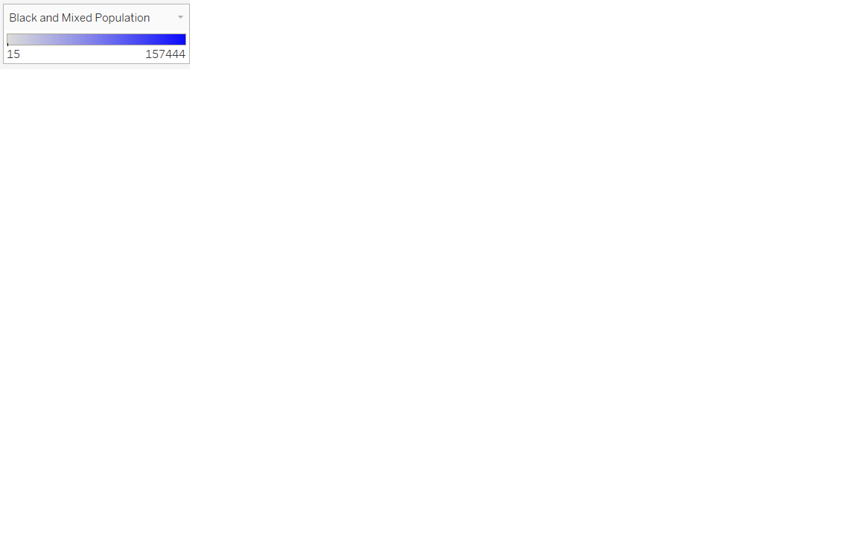

15 157,444

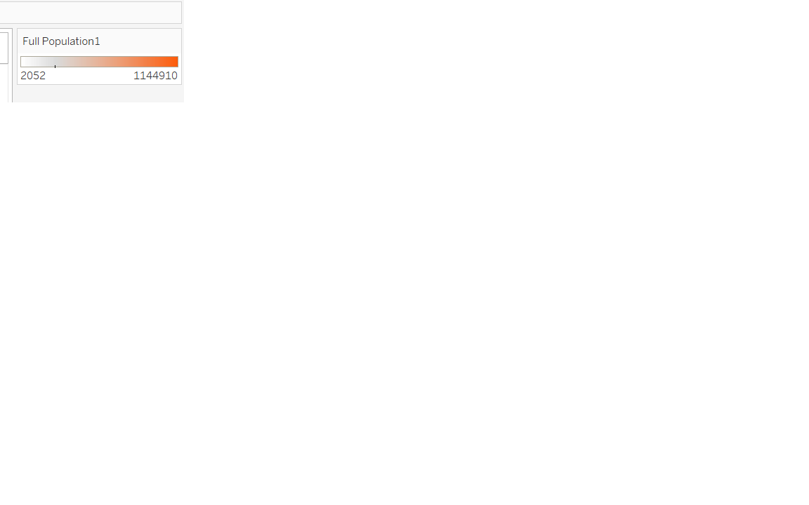

2052 1,144,910

a)

b)

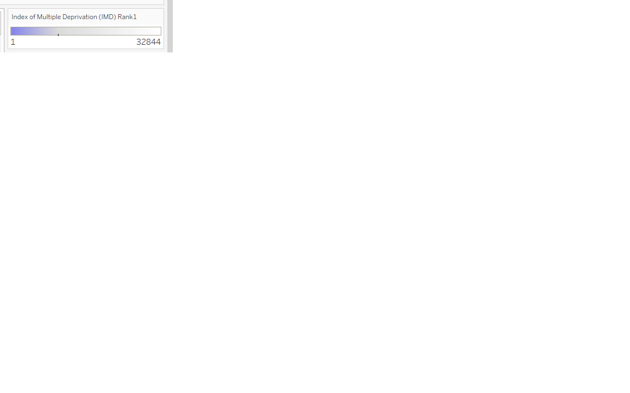

10 32,782

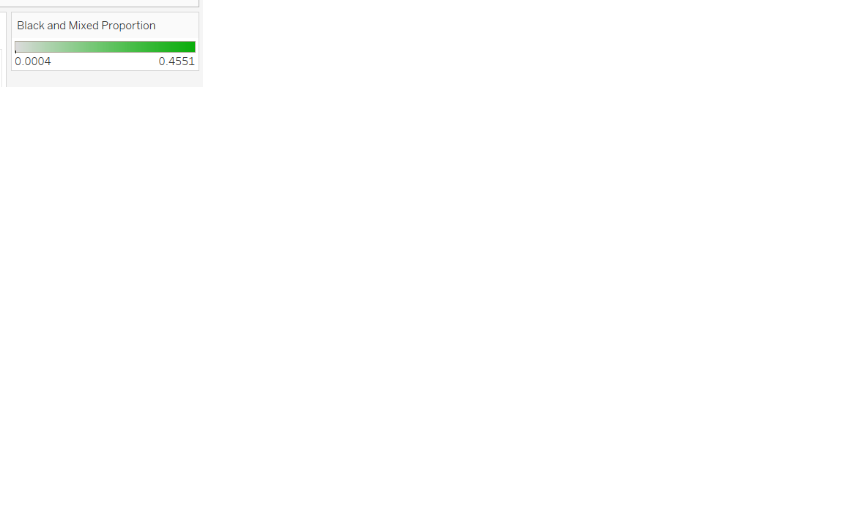

0.32% 45.41%

c)

d)

**Figure 1:** Demographic maps from UK Census 2021 [65] and the Indices of Multiple Deprivation 2019 [66]; **a)** shows the total number of people in each local authority in England & Wales, **b)** shows the total number of Black and Mixed Black people in each local authority in England & Wales, **c)** shows the proportion of Black and Mixed Black people in each local authority in England & Wales, and **d)** shows the worst deprivation ranking of each local authority in England, with 1st corresponding to the most deprived area.

Figure 1 shows four maps showing demographic information by local authority, with data being drawn from the UK Census 2021 and the Indices of Multiple Deprivation 2019. Figure 1a shows the total number of people in each local authority. The most populous local authority is Birmingham; with 1,144,910 people, and the least populous is the Isles of Scilly with 2052 people. When comparing this to Figure 1b, it shows that local authorities with the highest and lowest Black and Mixed Black population in England & Wales are also Birmingham and Isles of Scilly (with 157,444 and 15 Black and Mixed Black people respectively). Figure 1c shows the proportionality of Black and Mixed Black people in each local authority as a percentage; Lewisham in South East London had the highest proportion of Black and Mixed Black population and Allerdale in Cumbria had the lowest proportion, with 45.41% and 0.32% respectively. Figure 1d shows the worst deprivation ranking in a local authority per the Indices of Multiple Deprivation (IMD ranking is by Lower layer Super Output Areas or LSOA and local authorities comprise many of these). The most deprived LSOA is Liverpool 019C which is within the Liverpool Local Authority, and the local authority with the least deprived LSOA was North Tyneside (North Tyneside 017D).

### Overall NHS England mental health utilisation

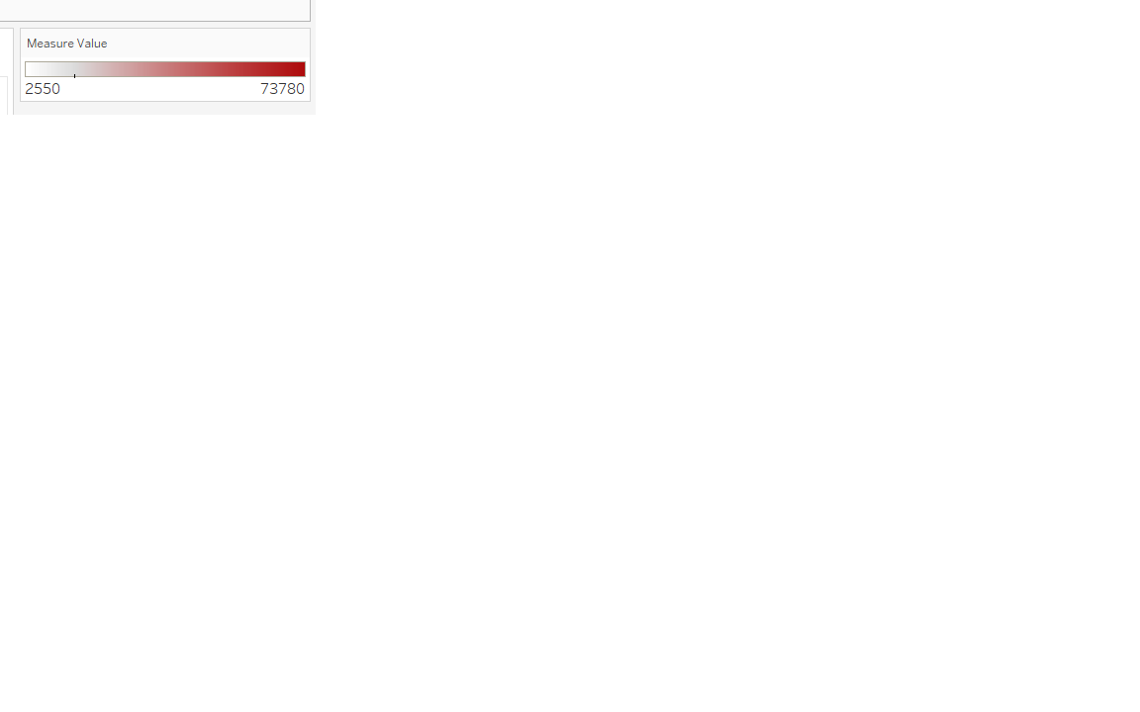

2550 73,780

**Figure 2:** The number of people in each sub-ICB who were in contact with mental health services in England on 31st July 2024, derived from NHS England Mental Health Services Monthly Statistics Performance data [76].

Figure 2 shows the number of people who were in contact with NHS mental health services at the end of July 2024, from the NHS England Mental Health Services Monthly Statistics Performance data. The sub-ICB with the most people in contact with NHS mental health services was the NHS Birmingham and Solihull ICB 15E sub-ICB, with 73,780 people, and the sub-ICB with the fewest people in contact with NHS mental health services was the NHS Staffordshire and Stoke-on-Trent ICB 04Y sub-ICB with 2550 people.

### Black and Mixed Black people and NHS Talking Therapies

a)

b)

c)

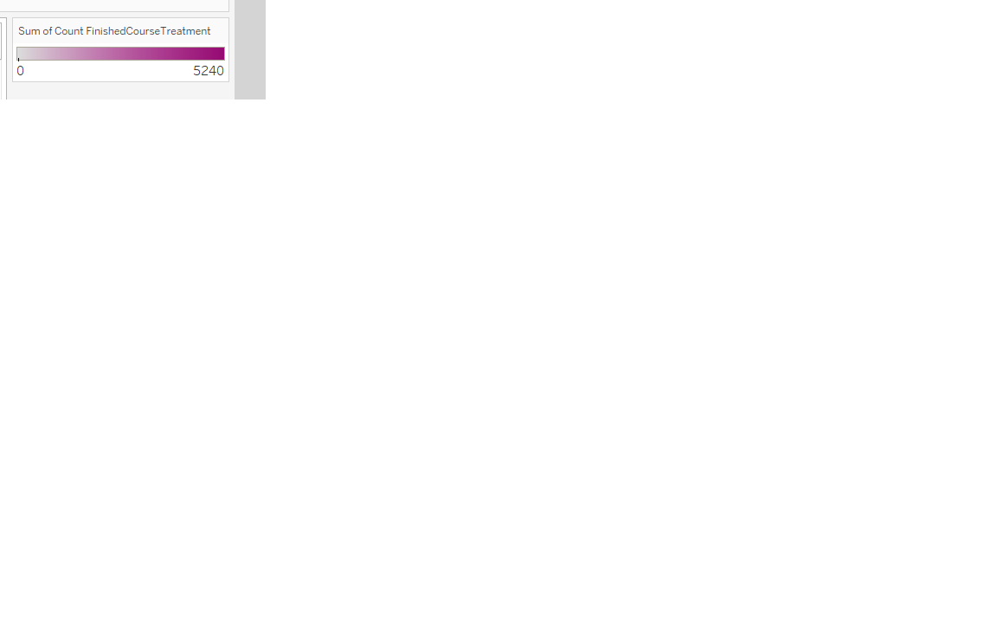

0 5240

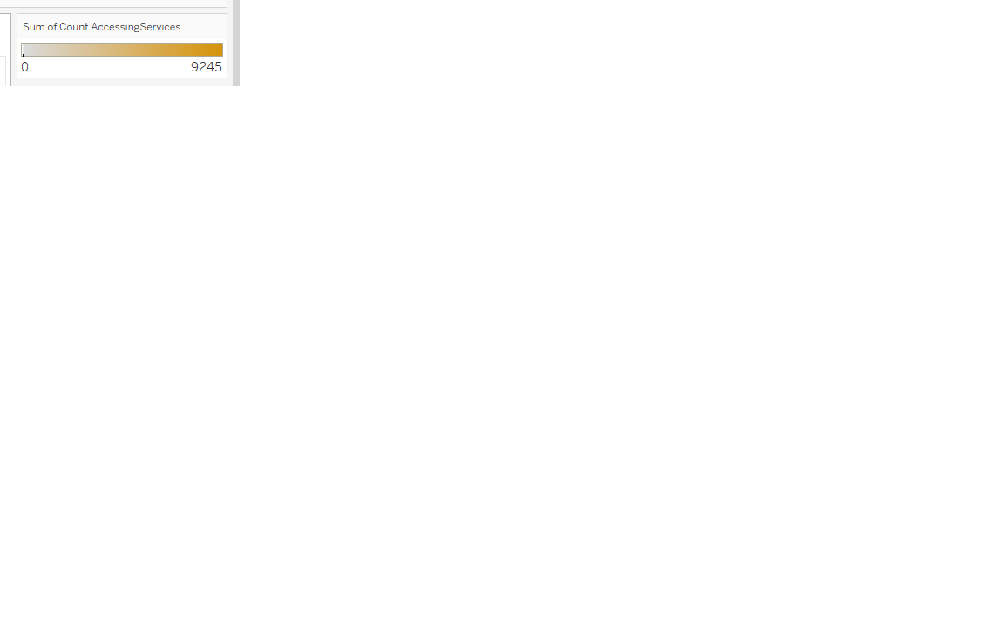

5 9245

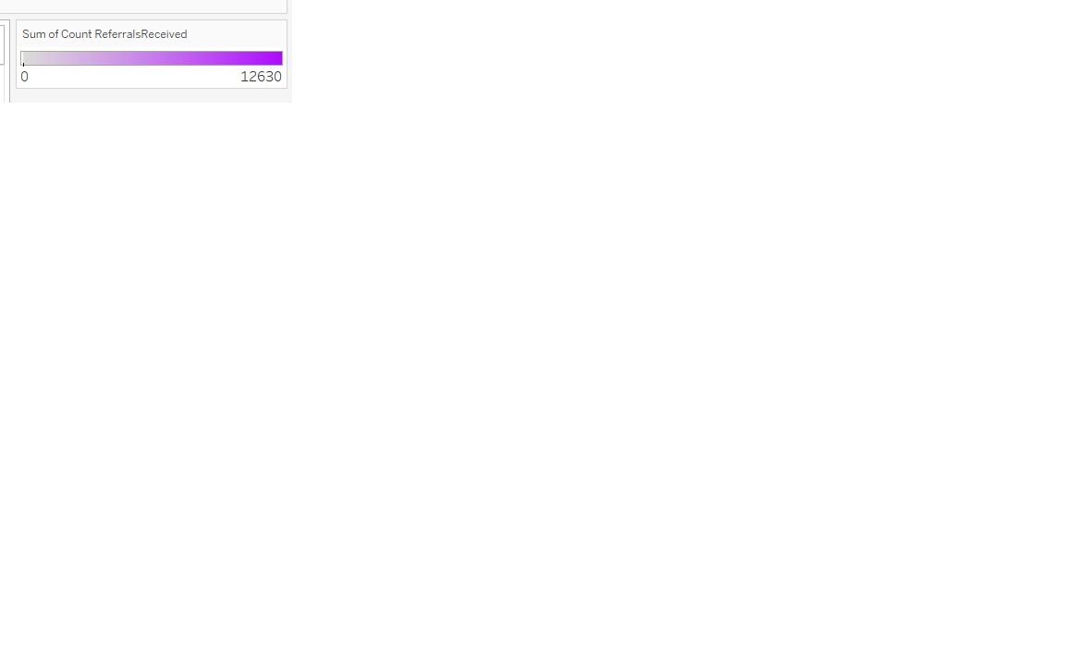

5 12,630

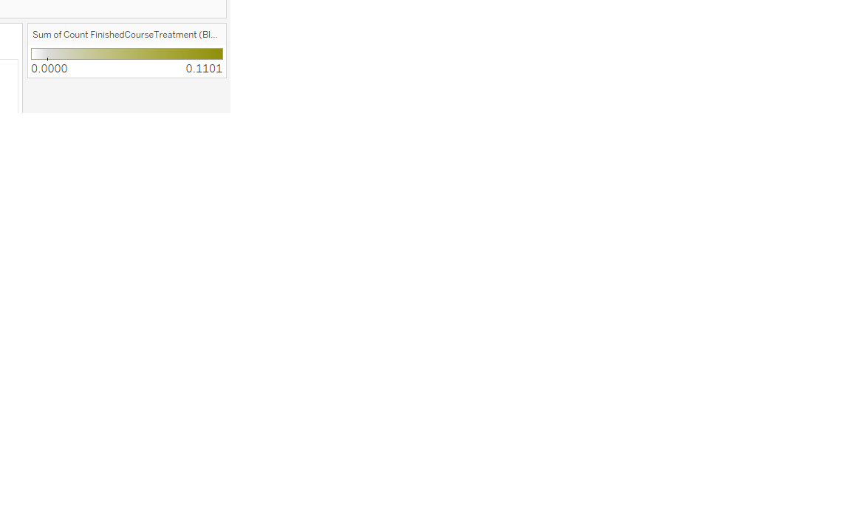

0.1% 11.01%

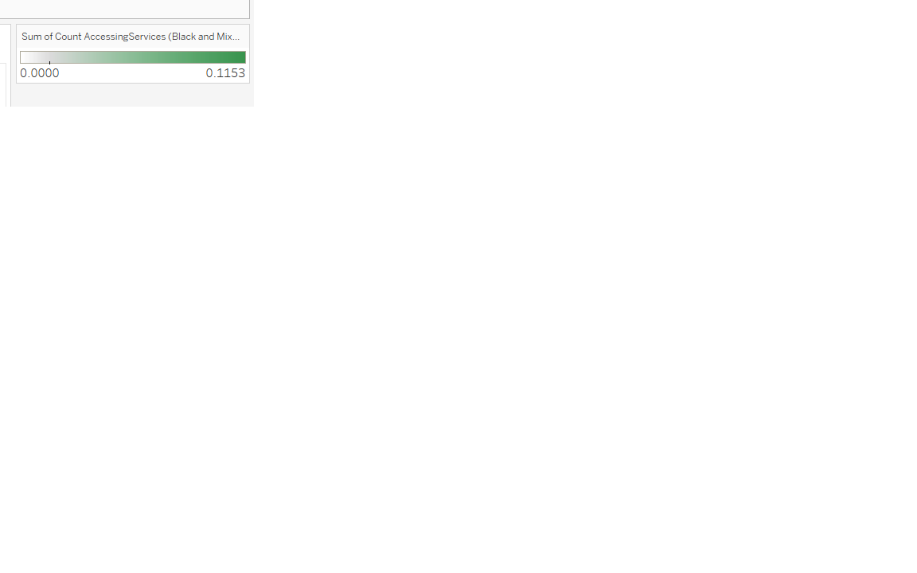

0.1% 11.53%

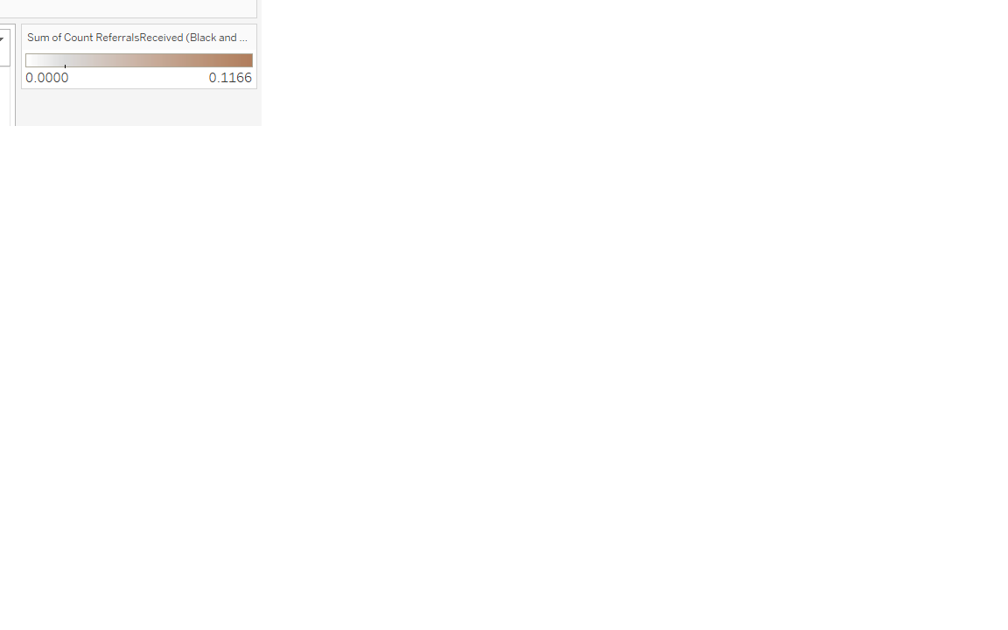

0.08% 11.66%

d)

e)

f)

**Figure 3:** NHS Talking Therapies data from their 2022-23 annual report [68]; **a)** shows the number of Black and Mixed Black people in each sub-ICB (Integrated Care Board) in England that were referred for NHS Talking Therapies, **b)** shows the number of Black and Mixed Black people in each sub-ICB (Integrated Care Board) in England that accessed care from NHS Talking Therapies, **c)** shows the number of Black and Mixed Black people in each sub-ICB (Integrated Care Board) in England that completed the course of care from NHS Talking Therapies, **d)** shows the proportion of Black and Mixed Black people in each sub-ICB (Integrated Care Board) in England that were referred for NHS Talking Therapies, **e)** shows the proportion of Black and Mixed Black people in each sub-ICB (Integrated Care Board) in England that accessed care from NHS Talking Therapies, **f)** shows the proportion of Black and Mixed Black people in each sub-ICB (Integrated Care Board) in England that completed the course of care from NHS Talking Therapies.

Figure 3 shows engagement data of Black and Mixed Black people with NHS Talking Therapies in the year 2022-23, per their annual report. The NHS South-East London ICB 72Q sub-ICB had the most engagement by Black and Mixed Black people, with 12,630 referrals, 9245 accesses and 5240 completed courses of care in 2022-23. The NHS South-East London ICB 72Q sub-ICB had the highest proportion of Black and Mixed Black people engaging with care with 11.66% of all referrals, 11.53% of all accesses and 11.01% of all completed courses being by Black and Mixed Black people. The NHS Cheshire and Merseyside ICB 01V sub-ICB had the fewest number of Black people engaging with NHS Talking Therapies in 2022-23, with five people being referred, all five of those people accessing care and none of them completing the course. The NHS North East and North Cumbria ICB 01H sub-ICB has the lowest proportion of Black and Mixed Black people engaging with NHS Talking Therapies, with 0.08% of all referrals, 0.1% of all accesses to care and 0.1% of all completions of care being by Black and Mixed Black people.

## Sentiment analysis

### Survey responses

**Figure 4:** The Likert scale positivity scores split by answer length in characters from the survey.

The survey collected 38 responses, 28 of these were responses with majority completed questionnaires. The number of usable nonempty survey answer pairs was 299. Figure 4 above shows the Likert-scale positivity score composition of the survey dataset split by answer length (in characters). 80.9% of answers were less than 200 characters in length, and there was only one answer greater than 600 characters. The distribution of positivity tends towards neutrality (there are fewer *Strongly Positive* and *Strongly Negative* answers than the rest), hence justifying the decision to compute precision, recall and F1-score on a weighted basis.

### Sentiment analysis outputs

Table 1 shows the performance of the models for the full set of usable survey answers. Accuracy, weighted precision, weighted recall and weighted F1-score can be seen for each of the four models. The baseline Twitter-roBERTa-base for sentiment analysis model outperforms the three machine learning models in accuracy (30.77%), weighted recall (31.00%) and weighted F1-score (29.93%) but the highest weighted precision was from the Support Vector Regressor with 51.45%.

**Table 1:** Performance (accuracy, weighted precision, weighted recall, weighted F1-score) of the Twitter-roBERTa-base for sentiment analysis model, Linear Regression, Support Vector Regressor and Random Forest Regressor on full survey answer dataset.

|  |  |  |  |  |
| --- | --- | --- | --- | --- |
| Model | Accuracy | Weighted precision | Weighted recall | Weighted  F1-Score |
| Twitter-roBERTa-base for sentiment analysis | 30.77% | 31.00% | 30.77% | 29.93% |
| Linear Regression | 22.07% | 26.77% | 25.08% | 24.01% |
| Support Vector Regressor | 27.43% | 51.45% | 27.43% | 20.01% |
| Random Forest Regressor | 26.09% | 28.58% | 26.09% | 23.84% |

Figure 5 shows the sentiment analysis performance (accuracy, weighted precision, weighted recall and weighted F1-score) of the four models split by answer length in 100 character intervals. Noting that there was only one answer each of length 500-599 characters and 700-799 characters and that there were none of length 600-699 characters, the average character length for all responses was 99 characters, with a two-standard deviation range of characters. Hence, answers greater than 327 characters can be considered anomalous. Nonetheless, the peak accuracy, weighted recall and weighted F1-score for the machine learning models is in the 300-399 character interval. The baseline Twitter-roBERTa-base for sentiment analysis model had its peak accuracy, weighted recall and weighted F1-score in the 200-299 character interval, and peak precision in the 300-399 interval. The least variance between the models is seen in the 100-199 character interval for accuracy, weighted recall and weighted F1-score, but this is seen in the 300-399 interval for weighted precision where all the models except Support Vector Regressor peak. The baseline model reached 77.78% precision, and Linear Regression & Random Forest Regressor both reached 72.22% precision.

a)

b)



c)

d)



**Figure 5:** The recorded accuracy (**a**), weighted precision (**b**), weighed recall (**c**) and weighted F1-score (**d**) of the Twitter-roBERTa-base for sentiment analysis model, Linear Regression, Support Vector Regressor and Random Forest Regressor in predicting the positivity score of the survey responses, split by answer length in characters. The two-standard deviation range was 0 < x < 327 characters. Outside of this range has been greyed. Note: there was only one answer each of length 500-599 characters and 700-799 characters, and there were none of length 600-699 characters.

Table 2 shows the prediction speed for each of the models for 20 repeated runs. The computation speed for each of the models is relatively consistent, with a range of only 6.2 ± 2.3 ms between the averages. The baseline Twitter-roBERTa-base for sentiment analysis model was the fastest with an average prediction speed of 47.8 ± 1.2 ms, and the Support Vector Regressor was the slowest with 54.0 ± 1.1 ms.

**Table 2:** Prediction speed for each of the models with 20 repeated runs.

|  |  |
| --- | --- |
| Model | Prediction speed |
| Twitter-roBERTa-base for sentiment analysis | 47.8 ± 1.2 ms |
| Linear Regression | 49.5 ± 0.6 ms |
| Support Vector Regressor | 54.0 ± 1.1 ms |
| Random Forest Regressor | 52.7 ± 0.7 ms |

## Qualitative analysis

### Survey participants

a)

b)

**Figure 6:** High-level demographic of survey participants. **a)** shows the age and gender identity distribution, and **b)** shows the Black and Mixed Black racial identity distribution.

The survey collected 38 responses, 28 of these were responses with majority completed questionnaires. Figure 6 shows the high-level demographic distribution of survey participants. It can be seen in Figure 6a that males aged 25-34 were the most represented demographic, and all participants aged 45 or older identified as female. Furthermore, 75% of respondents identified as Black, while the remainder identified as Mixed Black.

### Likert scale positivity scores

Figure 7 shows the count of Likert scale positivity score for each question. It is seen that *Neutral* was the most commonly given answer with 74 (24.75%), and that the extreme answers (*Strongly Positive* and *Strongly Negative*) were only given as answers 93 times (31.10%).

**Figure 7:** Overall distribution of positivity scores from the survey.

Table 3 below lists each question, the topic area, the average positivity value and score and the median and mode positivity scores. Like what is seen in Figure 7 above, the average and median positivity scores are localised in the nonextreme answers (*Positive*, *Neutral* and *Negative*), however, the modal score was *Strongly Positive* for Question 12, that discussed the potential for a black-centred app to be introduced that destigmatises mental health and promotes positive behaviours in Black community.

**Table 3:** The average, median and mode Likert scale positivity scores for each question.

|  |  |  |  |  |  |
| --- | --- | --- | --- | --- | --- |
| Question | Topic | Average positivity value | Average positivity score | Median positivity score | Mode positivity score |
| 1 | Personal access to informal mental health support | 0.29 ± 0.0044 | Positive | Positive | Positive |
| 2 | Informal mental health support available in Black community | -0.24 ± 0.0036 | Negative | Negative | Negative/Neutral |
| 3 | Need (or lack of need) to improve mental health in Black community | 0.46 ± 0.0069 | Positive | Neutral | Strongly Positive |
| 4 | Mental health services in Black community | -0.34 ± 0.0051 | Negative | Negative | Negative |
| 5 | Depression in Black community | -0.18 ± 0.0030 | Neutral | Negative | Negative |
| 6 | Anxiety in Black community | -0.26 ± 0.0044 | Negative | Negative | Negative |
| 7 | Struggle in Black community | -0.32 ± 0.0054 | Negative | Negative | Strongly Negative |
| 8 | Materialism in Black community | -0.31 ± 0.0052 | Negative | Negative | Strongly Negative |
| 9 | Religious support in Black community | 0.14 ± 0.0025 | Neutral | Neutral | Positive/Neutral |
| 10 | Hate/hatred in Black community | -0.13 ± 0.0023 | Neutral | Neutral | Negative |
| 11 | Potential for digital interventions for mental health in Black community | 0.22 ± 0.0039 | Positive | Neutral | Neutral |
| 12 | Potential for black-centred app destigmatising mental health and promoting positive behaviours in Black community | 0.53 ± 0.0095 | Positive | Strongly Positive | Strongly Positive |

### Themes

A systematic thematic analysis was conducted to draw prevalent recurring themes from survey responses. These have been presented by question topic below (full questions can be seen in Appendix B).

#### Question 1

This question asked participants about their informal access to mental health support. Nine people stated that they accessed support through conversations with their close network while seven reported that they could access support through their workplace.

#### Question 2

This question asked participants about informal mental health support in the Black community. Most responses stated that they felt that support was largely non-existent and needed improvement, with some offered explanations such as stigma, a lack of understanding and a community-wide refusal to acknowledge these problems. Conversely, five participants did express that they believed that the informal support in the Black community has improved over the years, and one stated that the younger generation is more aware of mental health issues.

#### Question 3

This question asked participants about the need (or lack of need) to improve mental health in the Black community. Responses stated that mental health in the Black community needs to be improved and that it is stigmatised and seen as a weakness; much of this being because of the specificities of the Black struggle. One participant stated that treatment rates in Black people were the lowest of all ethnic groups, while others stated that they assumed that high-quality care would be expensive. Some people did state that they felt supported personally while others offered ideas for interventions such as the need for Black therapists.

#### Question 4

This question asked participants about their opinion of mental health services in the Black community. Most responses stated that there is no Black specific support, and that improvement is desperately needed. Some note that there are general services that can be accessed, but provisions in the Black community are likely to be poor, based on what is seen in the wider system.

#### Question 5

This question asked participants about their opinion of depression in the Black community. Though some responses stated that they felt there was only a moderate level of depression in the Black community, the overwhelming majority stated that the levels were high, especially among those from lower socioeconomic backgrounds. Some participants felt that this was not necessarily a reflection on the Black community, as they believed that rates are probably similar across all ethnicities. Responses also stated that depression and its signs were stigmatised, not spoken about openly and often overlooked in the Black community.

#### Question 6

This question asked participants about their opinion of anxiety in the Black community. Most responses stated that anxiety was prevalent and normalised in the Black community, and some theorised that symptoms manifest in the aggressions seen against each other. One went as far as to call it a “ticking time bomb”.

#### Question 7

This question asked participants about their opinion of struggle in the Black community. Most responses stated that there is a high level of struggle, and offered explanations such as economics, current sociopolitical racial relations, imposter syndrome and generational trauma.

#### Question 8

This question asked participants about their opinion of materialism in the Black community. 82% of participants thought that there was a high level of materialism, some blamed popular culture, social media and a need for validation. One response stated that they believe its effects are evident in the rates of theft and robbery that are currently seen among young people.

#### Question 9

This question asked participants about their opinion of religious support in the Black community. Most responses stated that there is a high level of religious support as it is intwined in Black culture. Some did state, however, that though this support is prevalent, they did not believe that there was any mental health specific support offered through church and there are limitations to what can be provided by religious organisations.

#### Question 10

This question asked participants about their opinion of hate/hatred in the Black community. Many responses stated that hate/hatred is at a high level, and did not limit this to racial aggravation from outside but included animosity within the Black community as well. Three responses stated self-hatred as a cause, and four responses referenced the rates of Black-on-Black violence as evidence for their claims.

#### Question 11

This question asked participants about their opinion of the potential for digital interventions for mental health in Black community. Ten responses stated that they felt that digital interventions could be beneficial or potentially beneficial, with advantages such as anonymity, improved access, cost and convenience reported. Three respondents stated that they were unsure of the potential that digital interventions could actually have.

#### Question 12

This question asked participants about their opinion of the potential for a Black-centred app destigmatising mental health and promoting positive behaviours in thex Black community. Most responses stated that a Black-centred app would be excellent or potentially good, with one response stating that they would like it to be integrated with access to formal support. Five responses stated that a potential pitfall could be a lack of digital literacy and access to internet services.

# Discussion

## Maps

Figure 1 shows that Black and Mixed Black people tend to be localised in the most densely populated areas. These areas likely have their own socioeconomic risks that potentially lead to worsened mental health outcomes across the entire population. This, however, is not necessarily seen in the IMD data in Figure 1d, as there are indeed areas with low Black and Mixed Black populations that are more deprived. Regardless, the local authorities with higher Black and Mixed Black populations are also high on the IMD ranking and hence, it can be deduced that Black and Mixed Black people are more likely to live in deprived areas. Due to the ethnic data being provided for local authority, the worst IMD ranking in a local authority was taken and displayed (IMD is ranked by LSOA and not by wider local authority). This perhaps was not the most robust way to present this information, but it was chosen rather than an average since many local authorities had a wide range of deprivation rankings within them.

Figure 2 and Figure 3 show mental health accesses of the population overall and Black and Mixed Black people to NHS Talking Therapies by sub-ICB. Though trends are inferable through visual examination, mental health data by local authority would have allowed for stronger conclusions to be drawn on whether Black people were accessing services at disproportionate rates. Black and Mixed Black proportions of people referred to NHS Talking Therapies were presented, but this was not compared to the per-capita population in a sub-ICB. This was not possible because sub-ICBs, though geographic, do not represent a geographic area where people are populated; it represents a geographic area where people receive care. Hence, there was no readily traceable demographic data to which the mental health statistics could be compared. Regardless, it was seen that NHS Birmingham and Solihull ICB operates over the same local authority that has the most Black and Mixed Black people; but again, the Birmingham local authority also has the most people overall, so having the most mental health accesses should be expected.

The NHS Talking Therapies data did include the proportion of people accessing care through various mediums such as in person, via telephony or via the Internet, but this was not provided split based on ethnicity. Another unfortunate omission from the data was ethnicity-grouped time to wait to be offered care. Had this been provided, any discrepancies between the rates of referral, access and completion on this basis could have been further scrutinised to understand what other influences on these there may be.

## Sentiment analysis

Overall, the baseline Twitter-roBERTa-base for sentiment analysis model performed better than the three machine learning models, though none performed well. The baseline Twitter-roBERTa-base for sentiment analysis model only achieved a 30.77% accuracy, a 31.00% precision, a 30.77% recall and a 29.93% F1-score. None of the machine learning models exceeded 30% on any of the performance metrics apart from the Support Vector Regressor with 51.45% precision. It was also seen that the baseline Twitter-roBERTa-base for sentiment analysis model also had the fastest prediction speed with an average of 47.8 ± 1.2 ms. Nevertheless, the machine learning algorithms still did not perform much worse than the performance of the baseline model.

Since prediction involved multinomial classification, the models were given a more difficult task than predicting a polar variable. In binary classifications, models are more likely to produce accidental correct classifications, as they only have a 50% chance of being incorrect (in a numerically balanced investigation). In these scenarios, the predictive performance of the models is likely to be misleadingly high. However, in this investigation with five possible classifications, the models have an 80% probability of being incorrect, hence, attempting multinomial classification may be the main driver for the exceptionally low performances. This does show that a 30% success rate is not much more successful than randomly selected classifications, though it is an uplift.

It is indeed pertinent to quantify what each of the performance metrics are showing. For all models apart from Support Vector Regressor, similar values are seen across the four metrics. Accuracy produces a simple proportion of all correctly classified predictions, but precision, recall and F1-score have their own nuance (see Section 3.1.3). The higher precision seen in the Support Vector Regressor (51.45%) indicates that it likely made fewer false positive classifications than the other three models, which is interesting especially considering the multinomial classification problem above. This may be explained by oversampling of negative data, since performance has been evaluated on a “one-vs-rest” basis (see Section 3.1.3), most of the data was indeed weighted towards negatives. Furthermore, it has been shown in previous research, such as by Moraes et al., that support vector can be effective in minimising the false positive rate [77], which is useful in applications where false positives are less preferable.

The baseline Twitter-roBERTa-base for sentiment analysis model had been trained on 58m tweets, while the machine learning models were trained on only 14,338 Amazon product reviews, which is magnitudes less than the baseline. Clearly, neither of these sources are topic-specific to mental health and the Black experience, so the models were unlikely to have received a rich enough source of data to guide their inferences and associations. The survey only garnered 28 responses that provided 299 individual answers. The work would have been better improved if there were hundreds or thousands of responses, which would have allowed for train and test data to have been drawn from the survey as a single source. This would have ensured that the train data was relevant to what the models were being tasked with predicting sentiment for. An alternate option would have been to perform a web-scrape style exercise of a social media channel such as Twitter. Though there is a possibility of this producing a much larger dataset, due to the resource required to conduct and categorise this, this would not have been feasible. Beyond this, a pertinent point of discussion is that since mental health is not openly or candidly discussed in the Black community; this is likely also the case on social media. Furthermore, it is also seen generally that sentiment analysis algorithms do not comprehend sarcasm well, and much of what is seen on social media is sarcastic, whereas sarcasm is not commonplace in survey responses. Therefore, utilising a survey for this type of investigation remains the preferable choice.

Text answers from the survey, on average, were 99 ± 6.6 characters in length. This is below the 140-character limit on tweets pre-2017 [78], and hence the baseline Twitter-roBERTa-base for sentiment analysis model should not have been stretched beyond its capabilities, though it has been noted that there were a few outlier length answers that exceeded 327 characters. Linear Regression and Random Forest Regressor seemed to perform well in predicting sentiment of a few of the longer answers, though there were only two longer than 500-characters. The machine learning models did, however, perform best in the 300-399 characters range, this may be because survey responses that are longer are likely to be those with more passionate and clearly articulated answers. The prediction speeds of the models did not vary beyond a noticeable range, but regardless, speed is not a metric that is as important as accuracy, precision, recall and F1-score when assessing performance of prediction. Nonetheless, it was seen that the slowest model, Support Vector Regressor had the highest precision; this may suggest an inverse relationship between faster prediction speeds and precision (their Pearson correlation coefficient was 0.65 – positive number due to slower speeds producing larger prediction times).

Some survey participants referred to previous entries when answering a question; this was an issue as the composition of the investigation treated each text answer-Likert scale pair as independent feature-label pairs. Hence, the models had no visibility of what had been previously answered. This may have contributed to the low performance seen across the board. Furthermore, some participants gave extremely short (one or two words) answers, and others appeared to have misunderstood the wording of the Likert-scale questions, as some clearly negative written answers were being scored as positive and vice versa. Other participants gave a Likert scale score, then justified why they gave that score in their text answer, rather than explaining how they felt about it. The expectation was that the Random Forest Regressor would best handle these outliers, but due to the low quantity of data, obvious outliers may not have been clear enough for the model to identify. From a general perspective, though there was basic pre-processing to filter non-alphanumeric characters, this does not protect against typing errors. Furthermore, models are also not well equipped to pick up tone and sarcasm [79, 80, 81], though in a serious survey such as this, this was not likely a problem. It is also confirmed that there may indeed be a disconnect between what people say and how they feel about it [82, 83]. These factors combined also contribute negatively to the models’ performance. It is possible that obvious trigger words for polarity were not necessarily used in the responses, especially since much of the discussion was based on topics that require a cultural or social understanding of the current societal context – which models are not aware of. This is likely to have also contributed to low performances.

## Qualitative analysis

Figure 7 shows the Likert scale scores from the survey. It shows these scores were likely to be non-extreme answers, with 68.90% of answers being either *Positive*, *Neutral*, or *Negative*. Previous Likert scale research suggests that survey participants less readily give answers on either extreme [84, 85, 86, 87], which has also been seen in responses in this investigation. Furthermore, Likert scale questions can be restrictive for participants, and can limit them to answer on a rigid linear scale which may not fit with how they feel about a topic [88]. Moreover, the wording of questions can result in leading to a particular answer, but it was seen that they generally did not feel this way based on their text responses.

The survey received more male participation than female, and 75% of participants identified as being from Black rather than from Mixed Black backgrounds. Most participants were aged 25-34. The sample was small, being less than the targeted 50 responses. In order to gain a more representative reflection of the opinions of Black and Mixed Black people in England & Wales, a future investigation would require many more people engaging with the analysis and providing their personal insight. Engagement above the age of 45 was limited to female participation only; this may be reflective of some of the opinions expressed in some responses that mental health is not traditionally discussed by patriarchal figures in the Black community. This reluctance by older Black males to discuss mental health has indeed been found in other qualitative research [89, 90, 91].

Social issues were discussed by many participants in varying degrees, with some highlighting issues that are symptoms or manifestation of poor mental health in the Black community while other responses highlighted issues that are contributors to it. Belonging to lower economic classes and a lack of access to opportunity was a recurring theme for various mental health related issues, and some stated that they believed this was a driving force for much of the crime that is seen today. Many of the participants also cited racism and not fitting into society as a source of distress and poor mental health in the Black community. The deprivation indices from the quantitative analysis (Figure 1d) do support these, as the areas with higher Black populations do also have a higher ranking on that list.

Since survey participants were anonymous, their area of residence was not recorded. A future investigation may seek to access this information to validate whether there is any association between the perception of Black mental health and the rates of NHS mental health utilisation where a participant lives. This would, further, require a much larger sample of participants from a range of regions in the country to reliably generalise the results.

## Ethical considerations

Data sources utilised within the quantitative analysis are publicly available and free to use via the Open Government Licence [92, 93]. These data are aggregated and anonymised so including them did not create any ethical concerns within this research. Conducting a survey, however, did produce ethical considerations. It was deemed important to protect participants’ personal data and ensure that they remain anonymous. The potential for distress caused by the sensitive nature of the topics in the survey were also mitigated through informed consent and participants’ being made aware of their right to withdraw at any point. This is evidenced in three responses declining to consent based on the participation information preface (see Section 8.3.2 in Appendix C).

# Conclusions

This investigation aimed to further understanding of Black mental health, the perceptions held on it by Black and Mixed Black people in England & Wales, and to explore whether sentiment analysis with machine learning models can be applied in this context through a survey. The quantitative analysis gave indicative information on the localisation of Black and Mixed Black people in England & Wales and identified that areas with more Black and Mixed Black people were likely to see higher NHS mental health utilisation. It also highlighted that Black and Mixed Black people are more likely to live in more deprived urbanised areas. NLP and machine learning models were unsuccessful in the sentiment analysis task; none of the models achieved higher than 31% accuracy, though the Support Vector Regressor achieved a 51.45% precision. It was seen that the length of a string does have an impact on the sentiment analysis performance of NLP and machine learning models, and future work should consider stricter lower and upper character limits within the successful ranges. The qualitative analysis found that Black and Mixed Black people believe that Black mental health needs further targeted provision and highlighted that poor mental health is a cause and a contributor to the societal problems that are seen in the Black community. Future work should aim to increase the robustness of the data collection, which would include greater quantity and quality of qualitative data. This would firstly result in thematic insights being a more representative reflection of the feelings of the entire Black and Mixed Black population, but would also allow for models to be better trained and hence produce more accurate predictions.

# References

|  |  |
| --- | --- |
| [1] | M. Salmon, “Invisible illness: More than meets the eye,” Harvard Health Publishing - Harvard Medical School, 1 May 2023. [Online]. [Accessed 2024]. |
| [2] | C. L. Pederson, K. Gorman-Ezell and G. Hochstetler-Mayer, “Invisible illness increases risk of suicidal ideation: The role of social workers in preventing suicide,” *Health & social work,* vol. 42, no. 3, pp. 183-186, 2017. |
| [3] | S. J. Denman, “Mental illnesses are not invisible: An insight into workplaces,” *International Journal of Disability, Development and Education,* vol. 62, no. 3, pp. 339-345, 2015. |
| [4] | A. L. Kundrat and J. F. Nussbaum, “The impact of invisible illness on identity and contextual age across the life span,” *Health Communication,* vol. 15, no. 3, pp. 331-347, 2003. |
| [5] | S. C. Marriott, E. K. Grov and M. T. Gonzalez, “Mental health signs relevant for an assessment tool suitable for student and novice nurses: A document analysis,” *Issues in Mental Health Nursing ,* vol. 43, no. 7, pp. 639-649, 2022. |
| [6] | S. J. Borowsky, L. V. Rubenstein, L. S. Meredith, P. Camp, M. Jackson-Triche and K. B. Wells, “Who is at risk of nondetection of mental health problems in primary care?,” *Journal of general internal medicine,* vol. 15, pp. 381-388, 2000. |
| [7] | J. Liang, B. E. Matheson and J. M. Douglas, “Mental health diagnostic considerations in racial/ethnic minority youth,” *Journal of child and family studies,* vol. 25, pp. 1926-1940, 2016. |
| [8] | S. Stewart-Brown, P. C. Samaraweera, F. Taggart, N.-B. Kandala and S. Stranges, “Socioeconomic gradients and mental health: implications for public health,” *The British Journal of Psychiatry,* vol. 206, no. 6, pp. 461-465, 2015. |
| [9] | S. Braithwaite and J. Holt-Lunstad, “Romantic relationships and mental health,” *Current Opinion in Psychology,* vol. 13, pp. 120-125, 2017. |
| [10] | M. C. Stetz, M. L. Thomas, M. B. Russo, T. A. Stetz, R. M. Wildzunas, J. J. McDonald, B. K. W. and J. A. Romano, “Stress, mental health, and cognition: a brief review of relationships and countermeasures,” *Aviation, Space, and Environmental Medicine,* vol. 78, no. 5, pp. B252-B260, 2007. |
| [11] | H. Tough, J. Siegrist and C. Fekete, “Social relationships, mental health and wellbeing in physical disability: a systematic review,” *BMC public health,* vol. 17, pp. 1-18, 2017. |
| [12] | J. K. Burns, “Poverty, inequality and a political economy of mental health,” *Epidemiology and psychiatric sciences,* vol. 24, no. 2, pp. 107-113, 2015. |
| [13] | J. Moncrieff, “The political economy of the mental health system: A Marxist analysis,” *Frontiers in Sociology,* vol. 6, p. 771875, 2022. |
| [14] | J. K. Burns, “Poverty, inequality and a political economy of mental health,” *Epidemiology and psychiatric sciences,* vol. 24, no. 2, pp. 107-113, 2015. |
| [15] | CFMHAS, “Social assessments and social outcomes,” Centre for Mental Health and Society, [Online]. Available: https://cfmhas.org.uk/social-assessments-and-social-outcomes/#:~:text=The%20relationship%20between%20social%20adversity,circumstances%20and%20limited%20social%20connections.. [Accessed August 2024]. |
| [16] | D. Cai, M. Zhu, M. Lin, X. C. Zhang and J. Margraf, “The bidirectional relationship between positive mental health and social rhythm in college students: A three-year longitudinal study,” *Frontiers in Psychology,* vol. 8, p. 1119, 2017. |
| [17] | C. Sakellariou, “Estimating bidirectional effects between social connectedness and mental health in adolescent students: Addressing biases due to endogeneity,” *PIos one,* vol. 18, no. 12, p. e0294591, 2023. |
| [18] | ONS, “Suicides in England and Wales: 2022 registrations,” Office for National Statistics, 19 December 2023. [Online]. Available: https://www.ons.gov.uk/peoplepopulationandcommunity/birthsdeathsandmarriages/deaths/bulletins/suicidesintheunitedkingdom/2022registrations. [Accessed August 2024]. |
| [19] | J. Y. Nazroo, K. S. Bhui and J. Rhodes, “Where next for understanding race/ethnic inequalities in severe mental illness? Structural, interpersonal and institutional racism,” *Sociology of Health & Illness,* vol. 42, no. 2, pp. 262-276, 2019. |
| [20] | T. N. Brown, “Race, racism, and mental health: Elaboration of critical race theory's contribution to the sociology of mental health,” *Contemporary Justice Review,* vol. 11, no. 1, pp. 53-62, 2008. |
| [21] | D. Edge, “Falling through the net—Black and minority ethnic women and perinatal mental healthcare: health professionals' views,” *General hospital psychiatry,* vol. 32, no. 1, pp. 17-25, 2010. |
| [22] | S. Caplan, “Intersection of cultural and religious beliefs about mental health: Latinos in the faith-based setting,” *Hispanic Health Care International,* vol. 17, no. 1, pp. 4-10, 2019. |
| [23] | A. Augsberger, Y. A. M. Dougher and H. C. Hahm, “Factors influencing the underutilization of mental health services among Asian American women with a history of depression and suicide,” *BMC health services research,* vol. 15, pp. 1-11, 2015. |
| [24] | L. R. Roberts, S. K. Mann and S. B. Montgomery, “Mental health and sociocultural determinants in an Asian Indian community.,” *Family & community health,* vol. 39, no. 1], pp. 31-39, 2016. |
| [25] | K. B. Tharaldsen, P. Stallard, P. Cuijpers, E. Bru and J. F. Bjaastad, “‘It’sa bit taboo’: a qualitative study of Norwegian adolescents’ perceptions of mental healthcare services,” *Emotional and behavioural difficulties,* vol. 22, no. 2, pp. 111-126, 2017. |
| [26] | R. Majors, “Black mental health and the new millennium: Historical and current perspective on cultural trauma and ‘everyday’racism in White mental health spaces—The impact on the psychological well-being of Black mental health professionals,” in *The international handbook of Black community mental health*, Emerald Publishing Limited, 2020, pp. 1-26. |
| [27] | J. Alvidrez, L. R. Snowden and D. M. Kaiser, “The experience of stigma among Black mental health consumers,” *Journal of Health Care for the Poor and Underserved,* vol. 19, no. 3, pp. 874-893, 2008. |
| [28] | S. Dinos, “Stigma creating stigma: a vicious circle,” *The Psychiatric Bulletin,* vol. 38, no. 4, pp. 145-147, 2014. |
| [29] | A. Memon, K. Taylor, L. M. Mohebati, J. Sundin, M. Cooper, T. Scanlon and R. D. Visser, “Perceived barriers to accessing mental health services among black and minority ethnic (BME) communities: a qualitative study in Southeast England,” *BMJ open,* vol. 6, no. 11, p. e012337, 2016. |
| [30] | I. Cummins, “The impact of austerity on mental health service provision: a UK perspective,” *International journal of environmental research and public health,* vol. 15, no. 6, p. 1145, 2018. |
| [31] | I. Kawachi and L. F. Berkman, “Social ties and mental health,” *Journal of Urban health,* vol. 78, pp. 458-467, 2001. |
| [32] | A. M. Bardone, T. E. Moffitt, A. Caspi, N. Dickson and P. A. Silva, “Adult mental health and social outcomes of adolescent girls with depression and conduct disorder,” *Development and psychopathology,* vol. 8, no. 4, pp. 811-829, 1996. |
| [33] | A. Memon, K. Taylor, L. M. Mohebati, J. Sundin, M. Cooper, T. Scanlon and R. De Visser, “Perceived barriers to accessing mental health services among black and minority ethnic (BME) communities: a qualitative study in Southeast England,” *BMJ open,* vol. 6, no. 11, p. e012337, 2016. |
| [34] | B. L. Cook, N. H. Trinh, Z. Li, S. S. Y. Hou and A. M. Progovac, “Trends in racial-ethnic disparities in access to mental health care,” *Psychiatric services,* vol. 68, no. 1, pp. 9-16, 2017. |
| [35] | R. Ferenc, A. Beszedes, L. Fulop and J. Lele, “Design pattern mining enhanced by machine learning,” in *21st IEEE international conference on software maintenance*, 295-304, 2005. |
| [36] | M. Zanoni, F. A. Fontana and F. Stella, “On applying machine learning techniques for design pattern detection,” *Journal of Systems and Software,* vol. 103, pp. 102-117, 2015. |
| [37] | H. Washizaki, H. Uchida, F. Khomh and Y.-G. Guéhéneuc, “Studying software engineering patterns for designing machine learning systems,” in *2019 10th International Workshop on Empirical Software Engineering in Practice (IWESEP)*, 2019. |
| [38] | C. Mair, G. Kadoda, M. Lefley, K. Phalp, C. Schofield, M. Shepperd and S. Webster, “An investigation of machine learning based prediction systems,” *Journal of systems and software,* vol. 53, no. 1, pp. 23-29, 2000. |
| [39] | K. Chowdhary and K. Chowdhary, “Natural language processing,” in *Fundamentals of artificial intelligence*, Springer, 2020, pp. 603-649. |
| [40] | A. Rajput, “Natural language processing, sentiment analysis, and clinical analytics,” *Innovation in health informatics,* pp. 79-97, 2020. |
| [41] | T. Bignall, S. Jeraj, E. Helsby and J. Butt, “Racial disparities in mental health,” *London: Race Equity Foundation,* 2019. |
| [42] | F. Keating and D. Robertson, “Fear, black people and mental illness: a vicious circle?,” *Health & social care in the community,* vol. 12, no. 5, pp. 439-447, 2004. |
| [43] | J. Arday, “Understanding mental health: what are the issues for black and ethnic minority students at university?.,” *Social Sciences,* vol. 7, no. 10, p. 196, 2018. |
| [44] | T. Grey, H. Sewell, G. Shapiro and F. Ashraf, “Mental health inequalities facing UK minority ethnic populations: causal factors and solutions,” *Journal of Psychological Issues in Organizational Culture,* vol. 3, no. S1, pp. 146-157, 2013. |
| [45] | T. Bignall, S. Jeraj, E. Helsby and J. Butt, “Racial disparities in mental health,” *VCSE health & mental wellbeing alliance,* 2019. |
| [46] | B. Hussain, A. Sheikh, S. Timmons, T. Stickley and J. Repper, “Workforce diversity, diversity training and ethnic minorities: The case of the UK National Health Service,” *International Journal of Cross Cultural Management,* vol. 20, no. 2, pp. 201-221, 2020. |
| [47] | N. Mantovani, M. Pizzolati and S. Gillard, “Engaging communities to improve mental health in A frican and A frican C aribbean groups: a qualitative study evaluating the role of community well‐being champions,” *Health & social care in the community,* vol. 25, no. 1, pp. 167-176, 2017. |
| [48] | J. Thornton, “Ethnic minority patients receive worse mental healthcare than white patients, review finds,” *BMJ,* 2020. |
| [49] | S. Hatch, S. Frissa, M. Verdecchia, R. Stewart, N. Fear, A. Reichenberg, C. Morgan, B. Kankulu, J. Clark, B. Gazard and R. Medcalf, “Identifying socio-demographic and socioeconomic determinants of health inequalities in a diverse London community: the South East London Community Health (SELCoH) study,” *BMC public health,* vol. 11, pp. 1-17, 2011. |
| [50] | T. J. Devonport, G. Ward, H. Morrissey, C. Burt, J. Harris, S. Burt, R. Patel, R. Manning, R. Paredes and W. Nicholls, “A Systematic Review of Inequalities in the Mental Health Experiences of Black African, Black Caribbean and Black‑mixed UK Populations: Implications for Action,” *Journal of Racial and Ethnic Health Disparities,* vol. 10, no. 4, pp. 1669-1681, 2023. |
| [51] | UK Legislation, “Mental Health Act 1983,” gov.uk, [Online]. Available: https://www.legislation.gov.uk/ukpga/1983/20/contents. [Accessed June 2024]. |
| [52] | P. Barnett, E. Mackay, H. Matthews, R. Gate, H. Greenwood, K. Ariyo, K. Bhui, K. Halvorsrud, S. Pilling and S. Smith, “Ethnic variations in compulsory detention under the Mental Health Act: a systematic review and meta-analysis of international data,” *The Lancet Psychiatry,* vol. 6, no. 4, pp. 305-317, 2019. |
| [53] | N. Mantovani, M. Pizzolati and D. Edge, “Exploring the relationship between stigma and help‐seeking for mental illness in African‐descended faith communities in the UK.,” *Health Expectations,* vol. 20, no. 3, pp. 373-384, 2017. |
| [54] | J. Chung and J. Teo, “Mental health prediction using machine learning: taxonomy, applications, and challenges,” *Applied Computational Intelligence and Soft Computing,* vol. 2022, no. 1, p. e9970363, 2022. |
| [55] | D. Leightley, V. Williamson, J. Darby, T. and F. N., “Identifying probable post-traumatic stress disorder: applying supervised machine learning to data from a UK military cohort,” *Journal of Mental Health,* vol. 28, no. 1, pp. 34-41, 2018. |
| [56] | A. E. Tate, R. C. McCabe, H. Larssonl, S. Lundström, P. Lichtenstein and R. Kuja-Halkola, “Predicting mental health problems in adolescence using machine learning techniques,” *PloS one,* vol. 15, no. 4, p. e0230389, 2020. |
| [57] | J. Holdsworth, “What is NLP?,” IBM, [Online]. Available: https://www.ibm.com/topics/natural-language-processing. [Accessed June 2024]. |
| [58] | M. Taboada, “Sentiment analysis: An overview from linguistics,” *Annual Review of Linguistics,* vol. 2, pp. 325-347, 2016. |
| [59] | M. Wankhade, A. C. S. Rao and C. Kulkarni, “A survey on sentiment analysis methods, applications, and challenges,” *Artificial Intelligence Review,* vol. 55, pp. 5731-5780, 2022. |
| [60] | S. Park and Y. Kim, “Building thesaurus lexicon using dictionary-based approach for sentiment classifcation and applications (SERA),” in *IEEE 14th international conference on software engineering research, management and*, 2016. |
| [61] | N. Singh and U. C. Jaiswal, “Sentiment Analysis Using Machine Learning: A Comparative Studyy,” *ADCAIJ: Advances in Distributed Computing and Artificial Intelligence Journal,* vol. 25, no. 1, pp. 2255-2863, 2023. |
| [62] | A. Mitra and S. Mohanty, “Sentiment analysis using machine learning approaches,” *Journal of Ubiquitous Computing and Communication Technologies (UCCT),* vol. 2, no. 03, pp. 145-152, 2020. |
| [63] | Y. Al Amrani, M. Lazaar and K. E. E. Kadiri, “Random forest and support vector machine based hybrid approach to sentiment analysis,” *Procedia Computer Science,* vol. 127, pp. 511-520, 2018. |
| [64] | D. L. Morgan, Integrating qualitative and quantitative methods: A pragmatic approach, Sage publications, 2013. |
| [65] | Office for National Statistics, “Census,” ONS, [Online]. Available: https://www.ons.gov.uk/census. [Accessed June 2024]. |
| [66] | Ministry of Housing, Communities & Local Government, “English indices of deprivation 2019,” UK Government, 2019. |
| [67] | N. Digital, “Mental Health Services Monthly Statistics,” NHS England, 2024. |
| [68] | NHS Digital, “NHS Talking Therapies, for anxiety and depression, Annual reports, 2022-23,” NHS England, 2024. |
| [69] | G. Norman, “Likert scales, levels of measurement and the “laws” of statistic,” *Advances in health sciences education,* vol. 15, pp. 625-632, 2010. |
| [70] | F. Barbieri, J. Camacho-Collados, L. Neves and L. Espinosa-Anke, “TWEETEVAL: Unified Benchmark and Comparative Evaluation for Tweet Classification,” School of Computer Science and Informatics, Cardiff University, United Kingdom, Cardiff, 2020. |
| [71] | T. C. Mills, “The classical linear regression model,” in *Analysing Economic Data: A Concise Introduction*, Springer, 2014, pp. 166-187. |
| [72] | H. Lee, J. Wang and B. Leblon, “Using linear regression, random forests, and support vector machine with unmanned aerial vehicle multispectral images to predict canopy nitrogen weight in corn,” *Remote sensing,* vol. 12, no. 13, p. 2071, 2020. |
| [73] | J. R. C. Arias, “Datasets for Sentiment Analysis,” zenodo, 2023. [Online]. Available: https://zenodo.org/records/10157504#:~:text=Sentiment%20labels%20are%20generated%20using,label%20generated%20using%20polarity%20score).&text=This%20dataset%20was%20used%20in%20the%20experimental%20phase%20of%20my%20research.. [Accessed 2024]. |
| [74] | P. Flach, “Performance evaluation in machine learning: the good, the bad, the ugly, and the way forward,” *Proceedings of the AAAI conference on artificial intelligence,* vol. 33, no. 1, pp. 9808-9814, 2019. |
| [75] | L. Zhang, K. Hua, H. Wang, G. Qian and L. Zhang, “Sentiment analysis on reviews of mobile users,” *Procedia Computer Science,* vol. 34, pp. 458-465, 2014. |
| [76] | NHS Digital, “Mental Health Services Monthly Statistics,” NHS Digital, 2024. [Online]. Available: https://digital.nhs.uk/data-and-information/publications/statistical/mental-health-services-monthly-statistics. [Accessed June 2024]. |
| [77] | D. Moraes, J. Wainer and A. Rocha, “Low false positive learning with support vector machines,” *Journal of Visual Communication and Image Representation,* vol. 38, pp. 340-350, 2016. |
| [78] | A. Rosen, “Tweeting Made Easier,” Twitter, 7 November 2017. [Online]. Available: https://blog.x.com/en_us/topics/product/2017/tweetingmadeeasier. [Accessed 2024]. |
| [79] | M. K. Bhakuni, K., Sonia, C. Iwendi and A. Singh, “Evolution and evaluation: Sarcasm analysis for twitter data using sentiment analysis,” *Journal of Sensors,* vol. 1, p. 6287559, 2022. |
| [80] | D. G. Maynard and M. A. Greenwood, “Who cares about sarcastic tweets? investigating the impact of sarcasm on sentiment analysis,” in *Lrec 2014 proceedings. ELRA*, 2014. |
| [81] | D. H. Farias and P. Rosso, “Irony, sarcasm, and sentiment analysis,” *Sentiment analysis in social networks,* pp. 113-128, 2017. |
| [82] | L. F. Feldman, “Feelings or words? Understanding the content in self-report ratings of experienced emotion,” *Journal of personality and social psychology,* vol. 87, no. 2, p. 266, 2004. |
| [83] | M. Knotts, “I feel like a hypocrite: A beginning teacher’s disconnect between beliefs and practice,” *English Teaching: Practive & Critique,* vol. 15, no. 2, pp. 221-235, 2016. |
| [84] | H. Van Laerhoven, H. J. van der Zaag‐Loonen and B. H. Derkx, “A comparison of Likert scale and visual analogue scales as response options in children's questionnaires,” *Acta paeddiatricia,* vol. 93, no. 6, pp. 830-835, 2004. |
| [85] | G. M. Sullivan and A. R. A. Jr., “Analyzing and interpreting data from Likert-type scales,” *Journal of graduate medical education,* vol. 5, no. 4, pp. 541-542, 2013. |
| [86] | P. A. Bishop and R. L. Herron, “Use and misuse of the Likert item responses and other ordinal measures,” *International journal of exercise science,* vol. 8, no. 3, p. 297, 2015. |
| [87] | J. F. Rocereto, M. Puzakova, R. E. Anderson and H. Kwak, “The role of response formats on extreme response style: A case of Likert-type vs. semantic differential scales,” *In Measurement and research methods in international marketing,* pp. 53-71, 2011. |
| [88] | S. Dolnicar, “/7-POINT “LIKERT SCALES” AREN’T ALWAYS THE BEST OPTION Their validity is undermined by lack of reliability, response style bias, long completion times and limitations to permissible statistical procedures,” *Annals of Tourism Research,* vol. 91, 2021. |
| [89] | N. C. Calloway, “The Mental Health of Black Men: A Problem of Perception,” *Challenge,* vol. 12, no. 1, 2006. |
| [90] | J. A. Mitchell, D. C. Watkins, D. Shires, R. A. Chapman and J. Burnett, “Clues to the blues: predictors of self-reported mental and emotional health among older African American men,” *American journal of men's health,* vol. 11, no. 5, pp. 1366-1375, 2017. |
| [91] | E. Yoon, C. Coburn and S. A. Spence, “Perceived discrimination and mental health among older African Americans: The role of psychological well-being,” *Aging & mental health,* vol. 23, no. 4, pp. 461-469, 2019. |
| [92] | NHS Digital, “Supporting open data and transparency,” NHS Digital, December 2022. [Online]. Available: https://digital.nhs.uk/services/supporting-open-data-and-transparency. [Accessed June 2024]. |
| [93] | UK Data Service, “FAQs about how to get data and our access policy,” UK Data Service, [Online]. Available: https://ukdataservice.ac.uk/help/access-policy/frequently-asked-questions-faqs-about-how-to-get-data-and-our-access-policy/#:~:text=Who%20can%20access%20census%20data,such%20as%20census%20boundary%20data.. [Accessed June 2024]. |

# Appendices

## Appendix A: Pre-survey multiple choice demographic questions

**Table 4:** List of pre-survey multiple choice demographic questions and their answer options.

|  |  |  |  |
| --- | --- | --- | --- |
| Question number | Question | Answer options | |
| 1 | Please select the Gender Identity that best describes you. | Male  Female  Non-binary | Other  Prefer not to say |
| 2a | Please select the Racial Identity that best describes you (multiple selections allowed). | Black  Black African  Black American  Black Arab  Black Asian  Black British  Black Caribbean  Black Irish  Black Polynesian  Mixed Black | Mixed Black African  Mixed Black American  Mixed Black Arab  Mixed Black Asian  Mixed Black British  Mixed Black Caribbean  Mixed Black Irish  Mixed Black Polynesian  Mixed Black South American  Prefer not to say |
| 2b | Please select, if any, the other Racial Backgrounds you identify as being from (multiple selections allowed). | Asian  Arab  European  North American | South American  White  No Other Racial Identity  Prefer not to say |
| 3 | Please select the age bracket you belong to. | 18 – 24  25 – 34  35 – 44  45 – 59 | 60 – 74  75+  Prefer not to say |

## Appendix B: Survey questions

**Table 5:** List of survey questions and their answer type.

|  |  |  |
| --- | --- | --- |
| Question number | Question | Answer type |
| 1a | Please explain in 1-2 sentences what you think of the presence and level of informal mental health support you personally have in your life. | Open-ended text-based |
| 1b | Please rate how positively you feel about the presence and level of informal mental health support you personally have in your life. | Likert scale |
| 2a | Please explain in 1-2 sentences what you think of the presence and level of informal mental health support in the Black community. | Open-ended text-based |
| 2b | Please rate how positively you feel about the presence and level of informal mental health support in the Black community. | Likert scale |
| 3a | Please explain in 1-2 sentences what you think of the need (or lack of need) to improve mental health in the Black community. | Open-ended text-based |
| 3b | Please rate how positively you feel about the need (or lack of need) to improve mental health in the Black community. | Likert scale |
| 4a | Please explain in 1-2 sentences what you think of the presence and level of mental health services for the Black community. | Open-ended text-based |
| 4b | Please rate how positively you feel about the presence and level of mental health services for the Black community. | Likert scale |
| 5a | Please explain in 1-2 sentences what you think of the presence and level of depression in the Black community. | Open-ended text-based |
| 5b | Please rate how positively you feel about the presence and level of depression in the Black community. | Likert scale |
| 6a | Please explain in 1-2 sentences what you think of the presence and level of anxiety in the Black community. | Open-ended text-based |
| 6b | Please rate how positively you feel about the presence and level of anxiety in the Black community. | Likert scale |
| 7a | Please explain in 1-2 sentences what you think of the presence and level of struggle in the Black community. | Open-ended text-based |
| 7b | Please rate how positively you feel about the presence and level of struggle in the Black community. | Likert scale |
| 8a | Please explain in 1-2 sentences what you think of the presence and level of materialism in the Black community. | Open-ended text-based |
| 8b | Please rate how positively you feel about the presence and level of materialism in the Black community. | Likert scale |
| 9a | Please explain in 1-2 sentences what you think of the presence and level of religious support in the Black community. | Open-ended text-based |
| 9b | Please rate how positively you feel about the presence and level of religious support in the Black community. | Likert scale |
| 10a | Please explain in 1-2 sentences what you think of the presence and level of hate/hatred in the Black community. | Open-ended text-based |
| 10b | Please rate how positively you feel about the presence and level of hate/hatred in the Black community. | Likert scale |
| 11a | Please explain in 1-2 sentences what you think the potential of digital interventions to improve mental health in the Black community. | Open-ended text-based |
| 11b | Please rate how positively you feel about the potential of digital interventions to improve mental health in the Black community. | Likert scale |
| 12a | Please explain in 1-2 sentences what you think the potential of a black-centred app destigmatising mental health and promoting positive behaviours in the Black community. | Open-ended text-based |
| 12b | Please rate how positively you feel about the potential of a black-centred app destigmatising mental health and promoting positive behaviours in the Black community. | Likert scale |

## Appendix C: Artefacts

The following is a list of the agreed artefacts for this research and a description of the contents of each directory.

### Datasets

#### Demographic_Data

Here, the UK Census data that was utilised in the quantitative analysis can be found in *Ethnic group (detailed).xlsx* and *Ethnic group (detailed) - preprocessed.xlsx*. The former is the dataset as downloaded from the source, while the latter contains changes required to produce the outputs.

#### Geographic_Spatial_Files

Here, there are two spatial zip files for local authority boundaries in England & Wales from 2019 and 2023 and one for sub-ICBs in England which were used for the mapping exercise.

#### Indices_of_Multiple_Deprivation

A single file containing the Indices of Multiple Deprivation dataset used for the quantitative analysis.

#### NHS_England_Mental_Health_Data

The *MHSDS Data_JulPerf_2024.xlsx* and *psych-ther-ann-rep-csv-2022-23-main-v2.xlsx* files contain the downloaded from source datasets used for the quantitative analysis on NHS mental health service and performance. *MHSDS Data_JulPerf_2024 preprocessed.xlsx* and *psych-ther-ann-rep-csv-2022-23-main-v2-preprocessed.xlsx* contain changes required to produce the outputs.

### Ethical_Approval

Here, the completed ethical approval form and the participant information sheet that participants agreed to before continuing to the survey can be found.

### Python_Code

The directory contains Python files for the sentiment analysis. *CardiffNLPResults.py*, *LinearRegression.py*, *RandomForestRegressor.py* and *SVMRegression.py* are the sentiment analysis outputs. *CardiffNLPResultsSpeedTest.py*, *LinearRegressionSpeedTest.py*, *RandomForestRegressorSpeedTest.py* and *SVMRegressionSpeedTest.py*

#### SurveyDatasets

Directory contains the survey dataset as a CSV file downloaded from Qualtrics.

#### TrainData

Directory contains the CSV utilised as training data for the models which was Amazon product reviews.

### Report_Graphs

Contains a single xlsx file that contains data that was used in the graphs within the report

### Survey_Dataset

Contains the survey dataset as a CSV file downloaded from Qualtrics.